# ASP.NET Fundamentals - Retake Exam

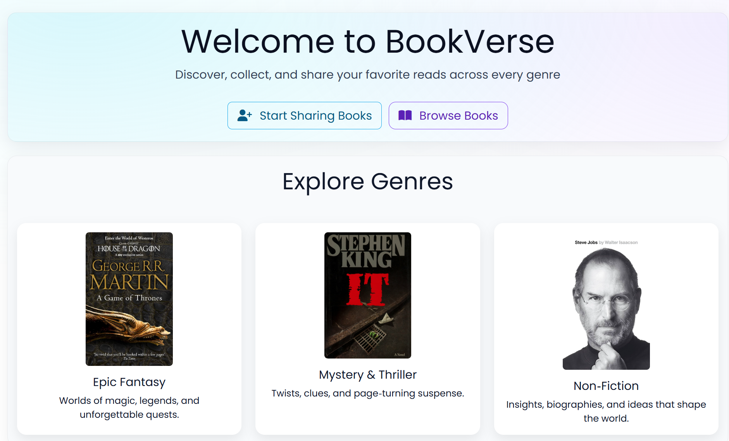

## Welcome to BookVerse

***BookVerse*** *is a web application where readers discover, share, and save their favorite books. Whether you love classic literature or the latest bestsellers, BookVerse gives users a place to explore, curate Favorites, and track popularity via a favorites counter. Logged-in users can publish books; everyone can browse and view details.*

## Technological Requirements and Overview

* Use the provided skeleton – [**BookVerse-Skeleton.zip**](http://svn.softuni.org/admin/svn/csharp-web/trunk/May-2025/ASP.NET-Fundamentals/10-Exam-Preparation/Horizons-Skeleton.zip)
* All required packages are preinstalled.

**The Technological Requirements are ABSOLUTE. If you do not follow them, you will NOT be scored for other Requirements.**

The provided solution consists of:

* Web/**Areas/Identity/Pages** – **scaffold Identity** here
* Web/**Controllers** – implement controller logic here
* **Data/** project – hold entity models and BookVerseDbContext here
* Web/**Views** – **provided views;** implement logic for logged-in/logged-out users
* Web/**appsettings.json** – update your **connection string**
* Web/**Program.cs** – configure **security and password requirements**
* Services**/Core** project – place **service interfaces** here (example: IEntityService in Contracts)
* Web/**ViewModels** project – place your **view models** here
* GCommon project – keep your **validation constants** here (ValidationConstants.cs)

**Seeding Note:** Seed the database with the pre-provided data for the **Genre** entity. To do this, **uncomment** the block inside **protected override void OnModelCreating(ModelBuilder builder)** method of the **DbContext.**

**Views Note: Don't forget to uncomment the code inside the views while you implement your logic.**

## Usage of Services — Mandatory Requirement

* All DB communication must go through **services**.
* **Controllers must not use DbContext directly**.
* Controllers call service methods; services handle DbContext.
* This will be explicitly checked. Using DbContext in controllers costs **Code Quality** points.

## Identity Requirements

**Scaffold** **Identity** and use the **default** **IdentityUser**.

⚠️ **Important! Delete the Unnecessary DbContext**

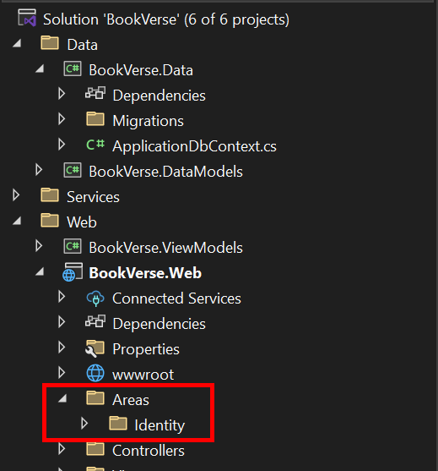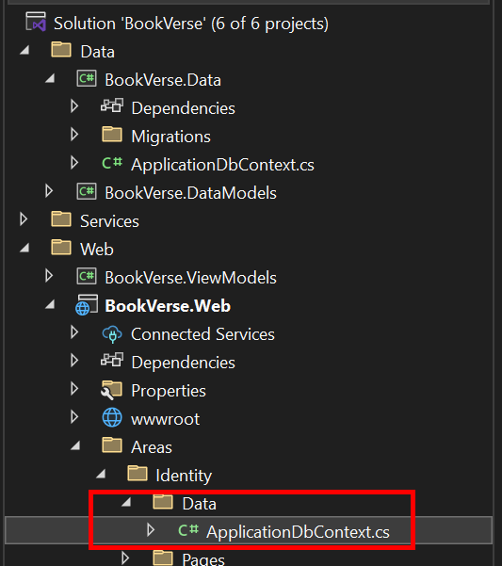

**After you scaffold Identity**, Visual Studio may **automatically generate** a file called ApplicationDbContext.cs inside **Areas** > **Identity** > **Data**.  
 **This file is not needed** for our project because we already have our own ApplicationDbContextin the main Web project:

* Locate the file **Areas**/**Identity**/**Data**/ApplicationDbContext.cs
* **Delete it immediately** to avoid DbContext conflicts in the application.

Remove the unnecessary code from the **Login.cshtml** and **Register.cshtml** files and leave only the needed code for the app to function correctly.

**NOTE: Don't worry about the views' style – once you scaffold Identity and remove the unnecessary code, the** [**Login**](#_Login_Page_(logged-out) **and** [**Register**](#_Register_Page_(logged-out) **pages should look like the ones shown below. Don't add any classes to the views of those two pages!**

The **password** requirements for the **IdentityUser** are the following:

* Require confirmed account: **false**
* Require digits: **false**
* Require non-alphanumeric characters: **false**
* Required uppercase letters: **false**
* Required lowercase letters: **false**

## Database Requirements

The **Database** of **BookVerse**:

### Book

* Has Id – a unique **integer, Primary Key**
* Has Title – a string with **min** length **3** and **max** length **80** (**required**)
* Has Description – string with **min** length **10** and **max** length **250** (**required**)
* Has **CoverImageUrl** – nullable string (**not required**)
* Has PublisherId – string (**required**)
* Has Publisher – IdentityUser (**required**) (*the logged-in user who added the book*)
* Has PublishedOn – DateTime with format "**dd-MM-yyyy**" (**required**)
  + *The* ***DateTime*** *format is only recommended*
* Has GenreId – **integer, foreign key (required)**
* Has Genre – Genre (**required**)
* Has IsDeleted – bool **(default value == false)**
* Has **UsersBooks** – a collection of type **UserBook**

### Genre

* Has Id – a unique **integer, Primary Key**
* Has Name – a string with min length **3** and max length **20** (**required**)
* Has **Books** – a collection of type **Book**

### UserBook (Favorites mapping)

* Has UserId – string, PrimaryKey, foreign key (**required**)
* Has User – IdentityUser
* Has BookId – integer, PrimaryKey, foreign key (**required**)
* Has Book – Book

Implement the entities with the **correct datatypes** and their **relations**.

**Feel free to use the new syntax for the realization of the many-to-many relation without a mapping table.**

## Page Requirements

### Index Page (logged-out user)

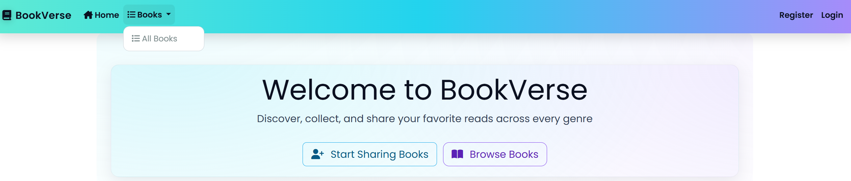

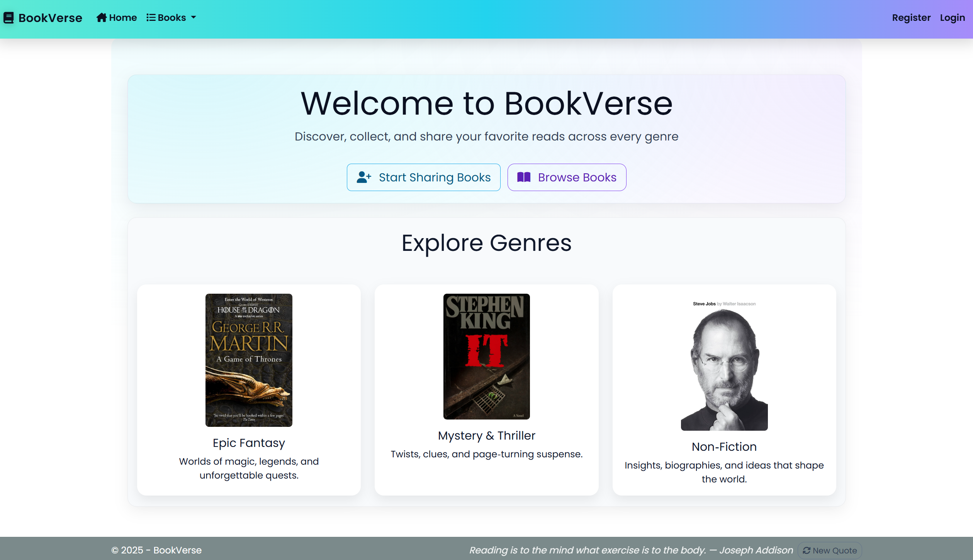

### Index Page (logged-in user)

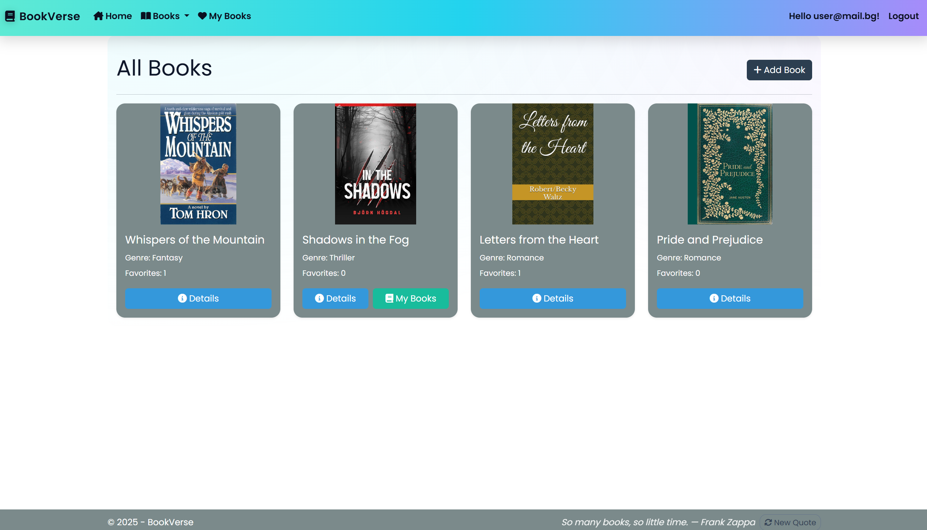

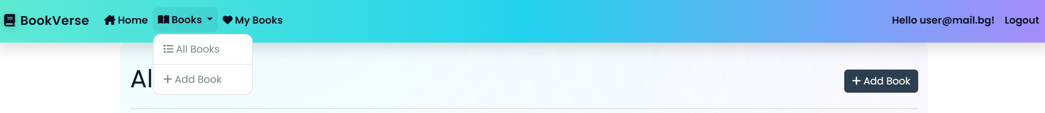

**Note: The Book Index Page** will have **different behavior** for **logged-in** and **not-logged-in** users. Also, **different book cards** will behave differently for **publishers** and **non-publishers**.

### /Book/Index (logged-out user)

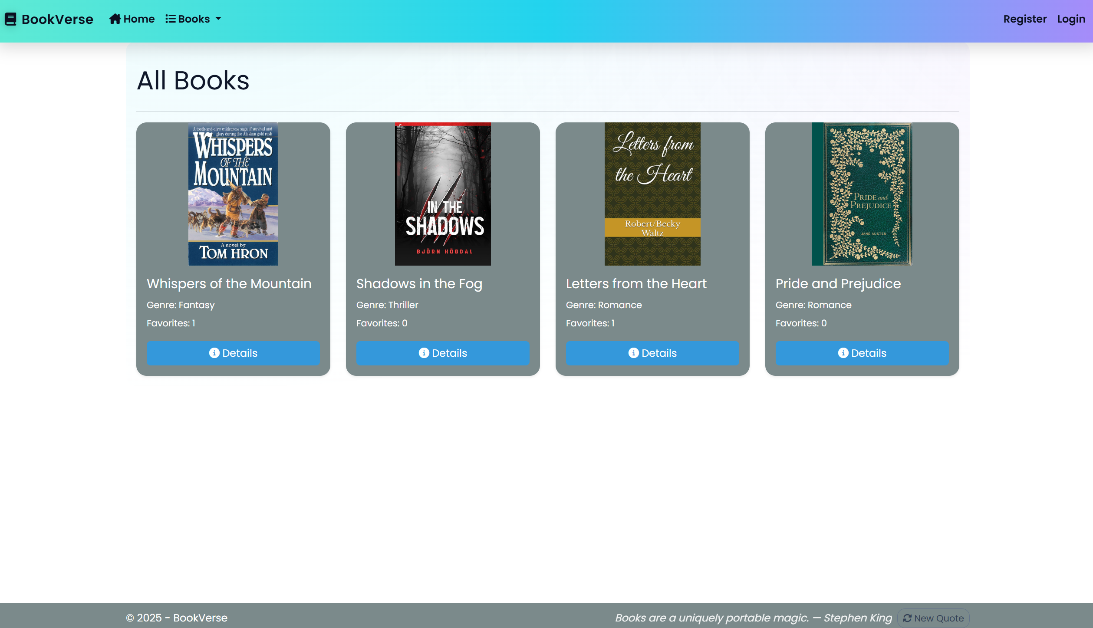

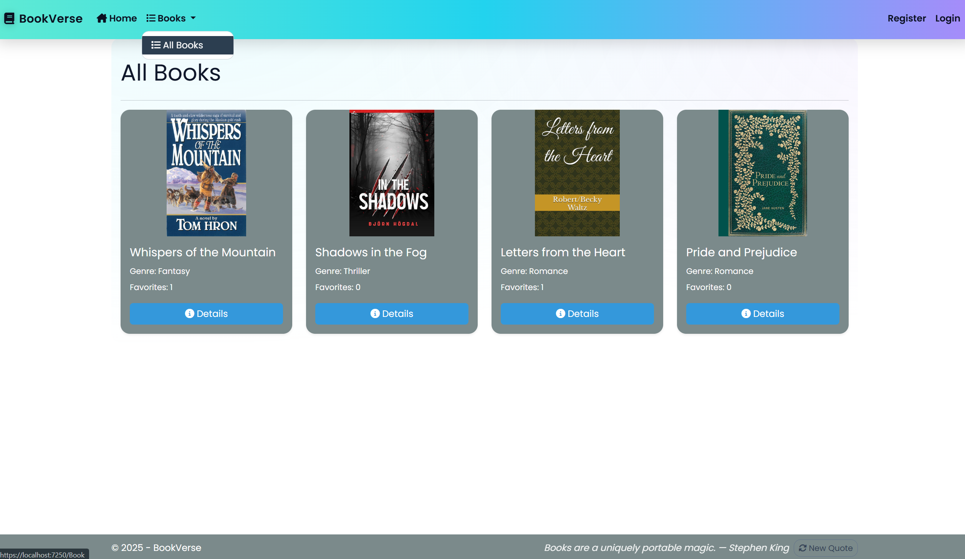

**NOTE**: If the current user is not **logged in** they will be still able to access the **/Book/Index** page

### Login Page (logged-out user)

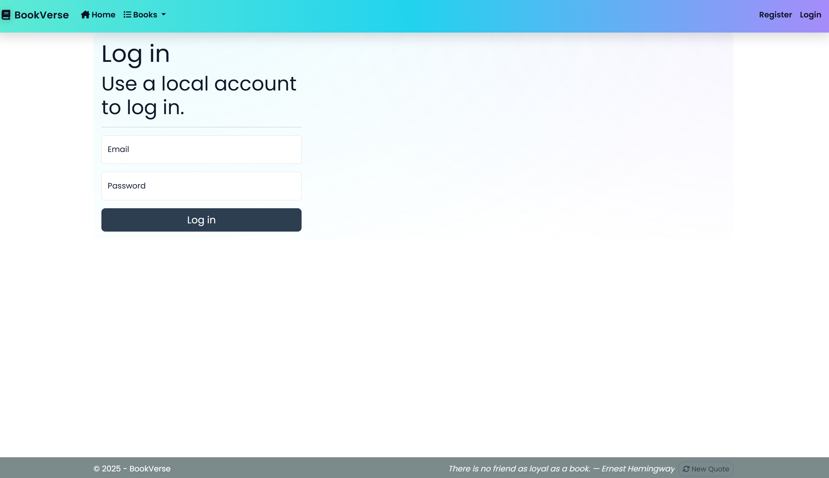

### Register Page (logged-out user)

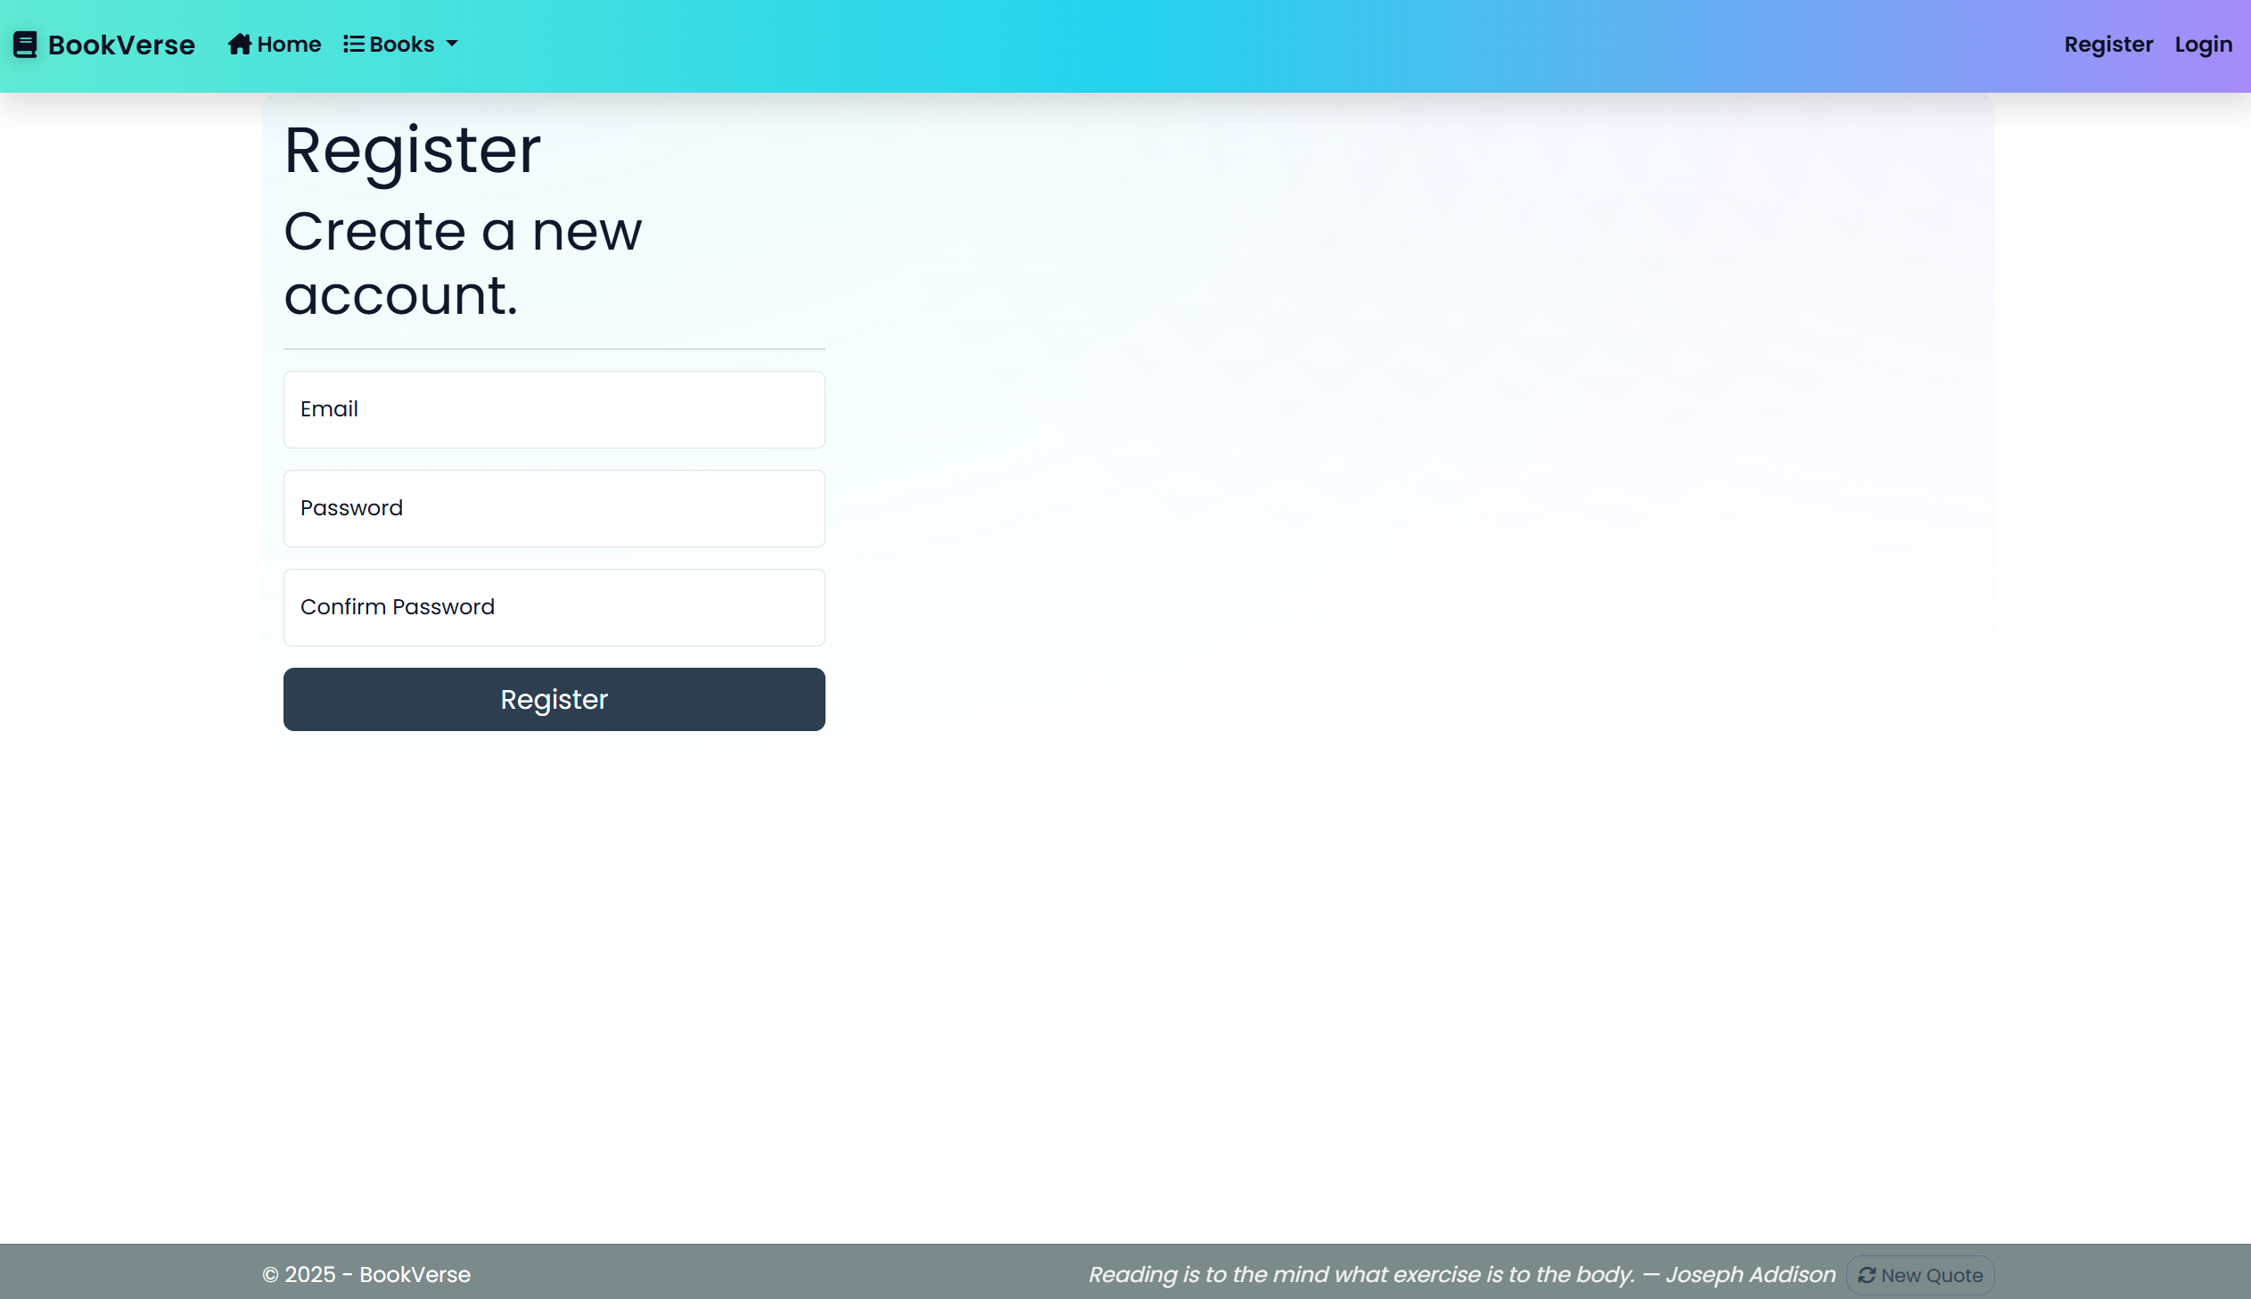

**Note: The Register Page** should be **accessible** from the **"Start Sharing Books" button** from the Index Page for  
(logged-out user)

### /Book/Create (logged-in user)

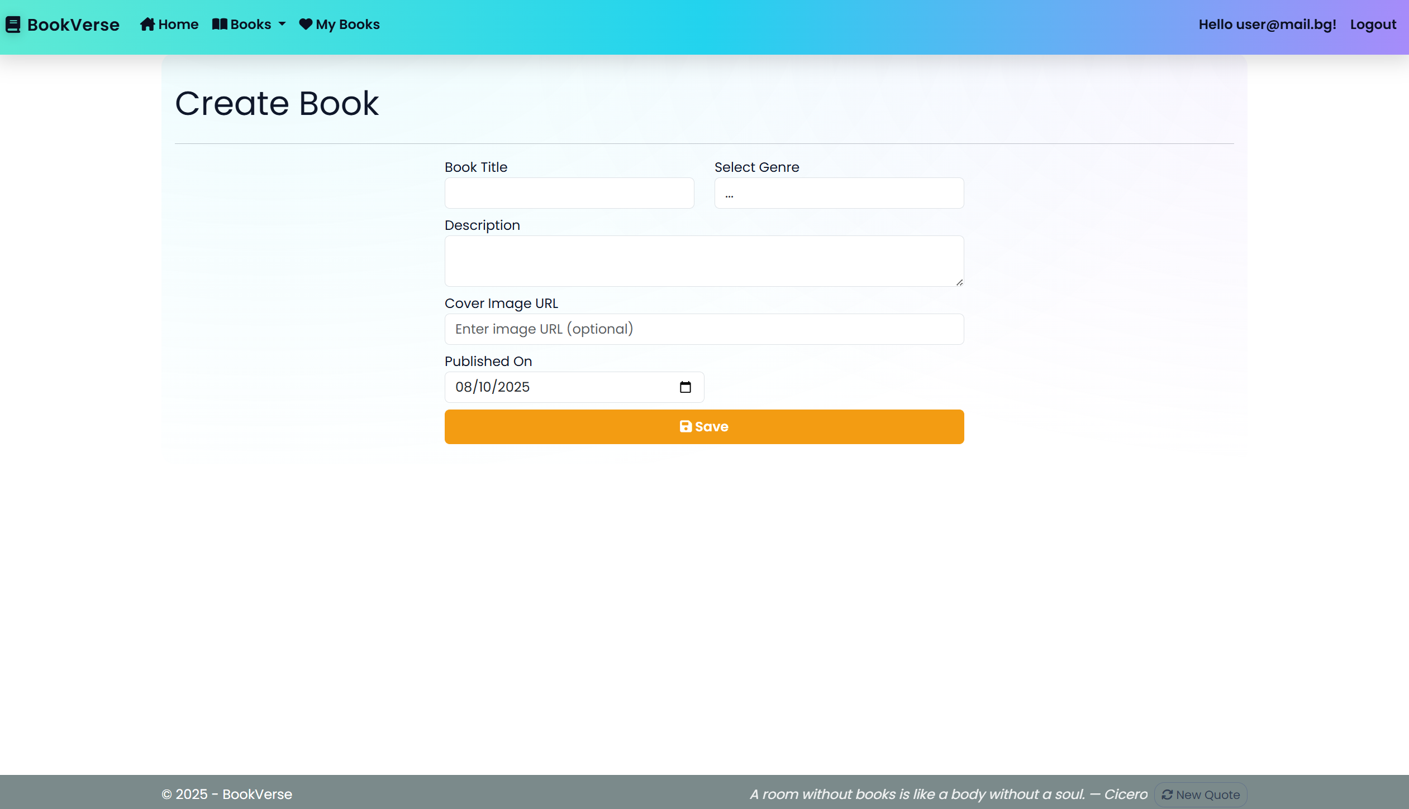

**NOTE:** the **DateTime** format is recommended, if you are having trouble with the one in the image, you are **free** to use **another** one.

### /Book/MyBooks (logged-in user)

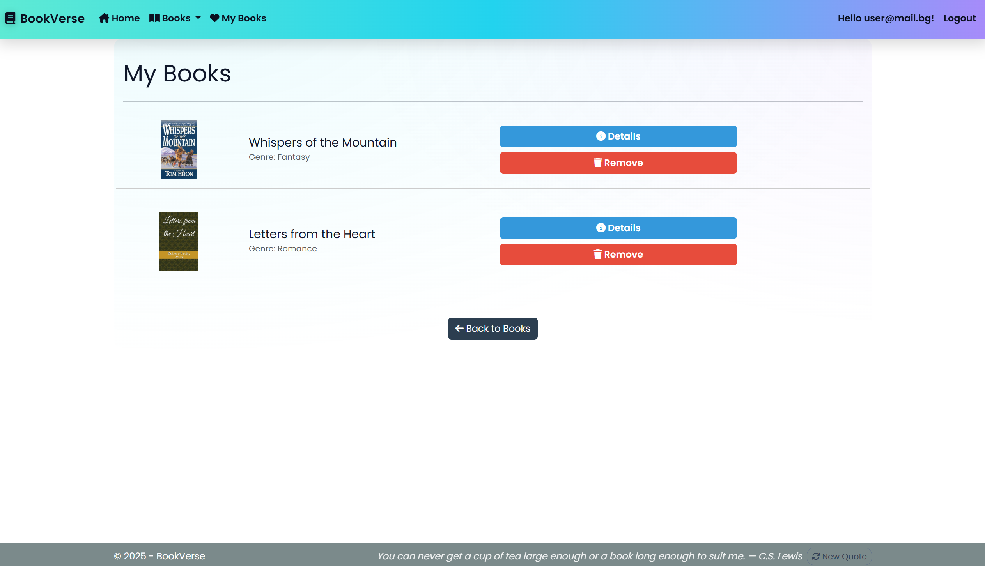

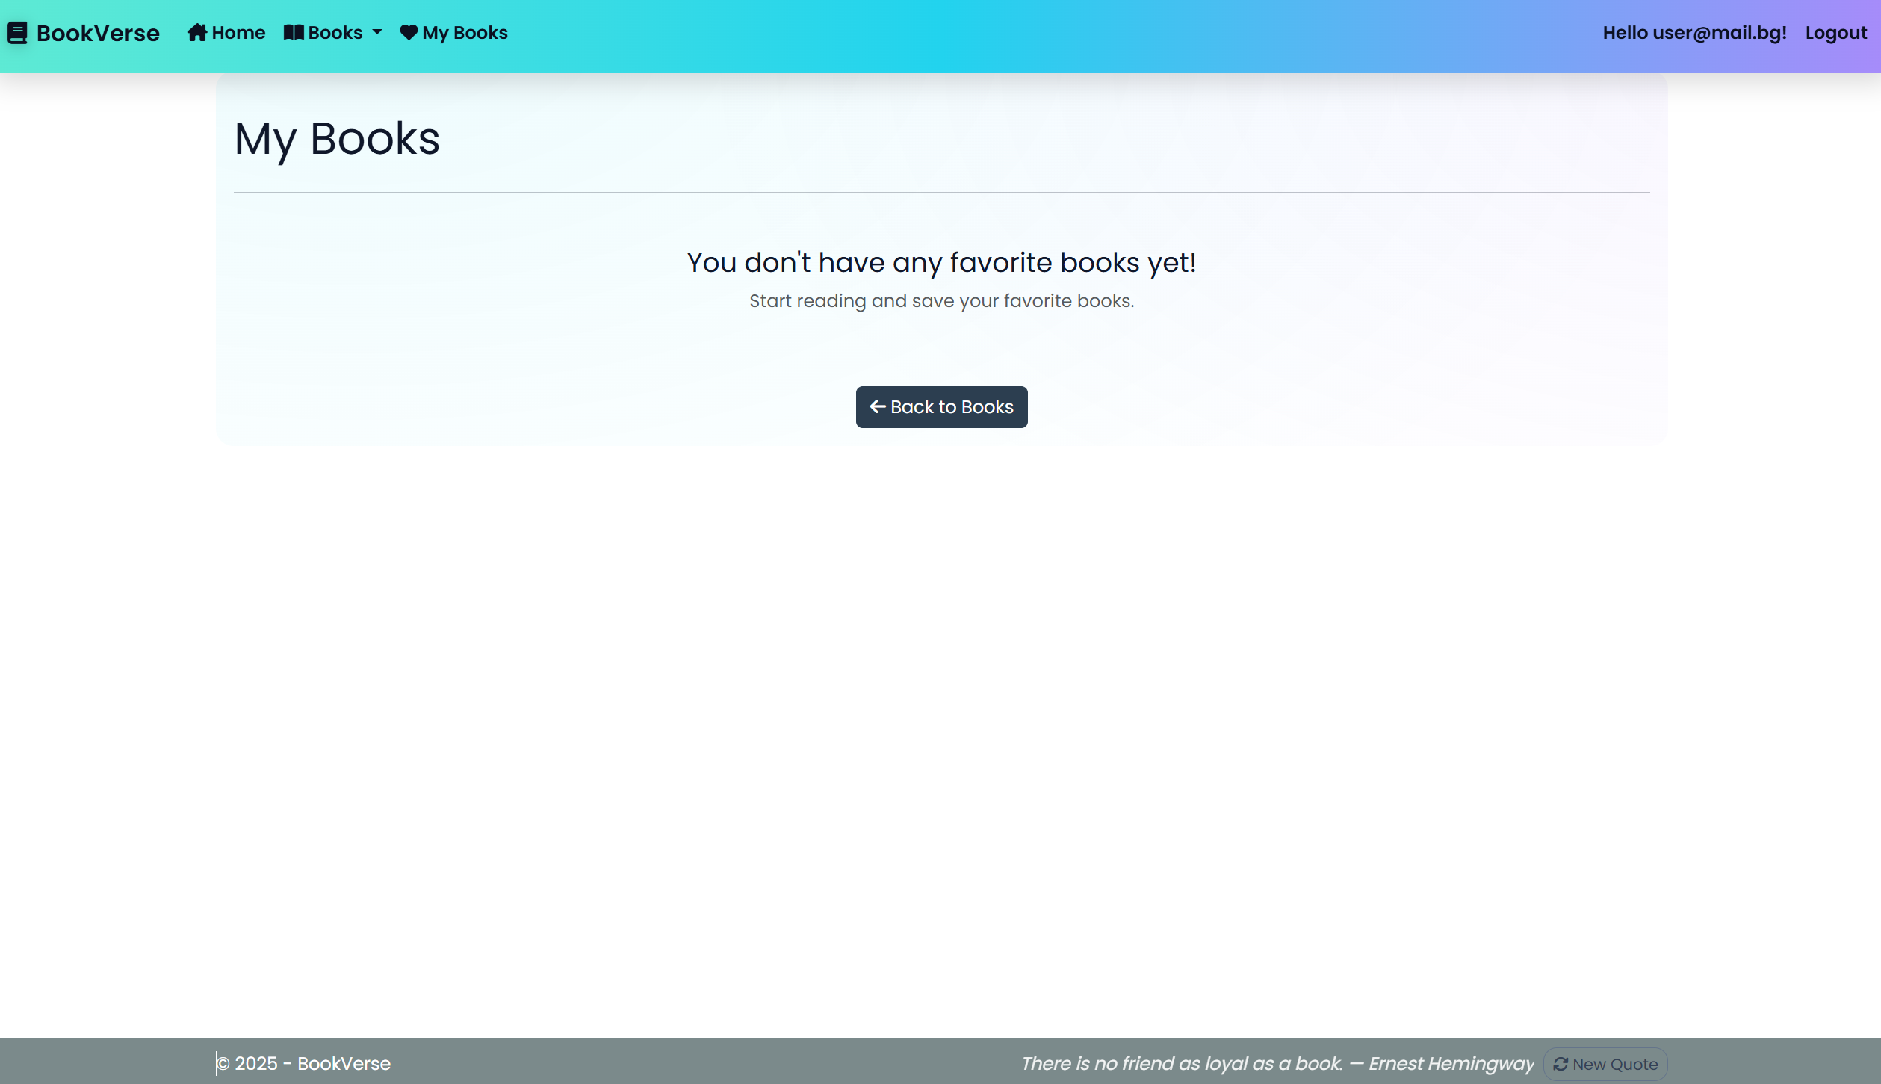

**NOTE**:

* When a user **removes a book** from **My Books** list, the application **should update the view** **without redirecting the user**
* If **no favorite books are left after a removal action**, the **user should remain on the same page** and see the following message: "You don't have any favorite books yet!"

**Book/Details/{id} (logged-in user, publisher of a book)**

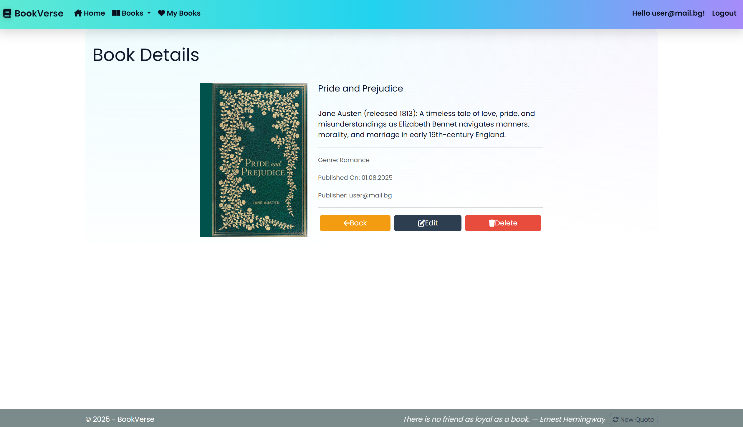

**Book/Details/{id} (logged-in user, not-publisher of a book, the book is not added to my books)**

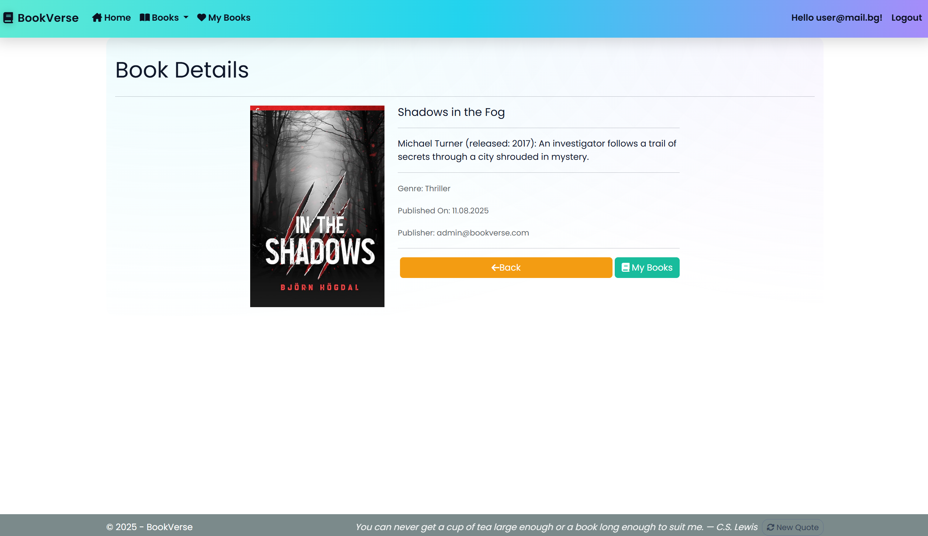

**Book/Details/{id} (logged-in user, not-publisher of a book, the book is already added to my books)**

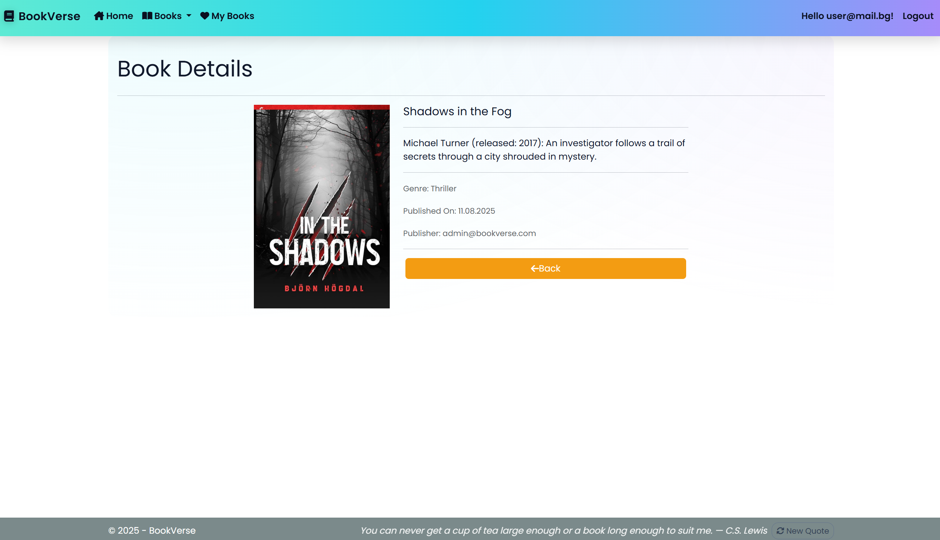

**Book/Details/{id} (guest user)**

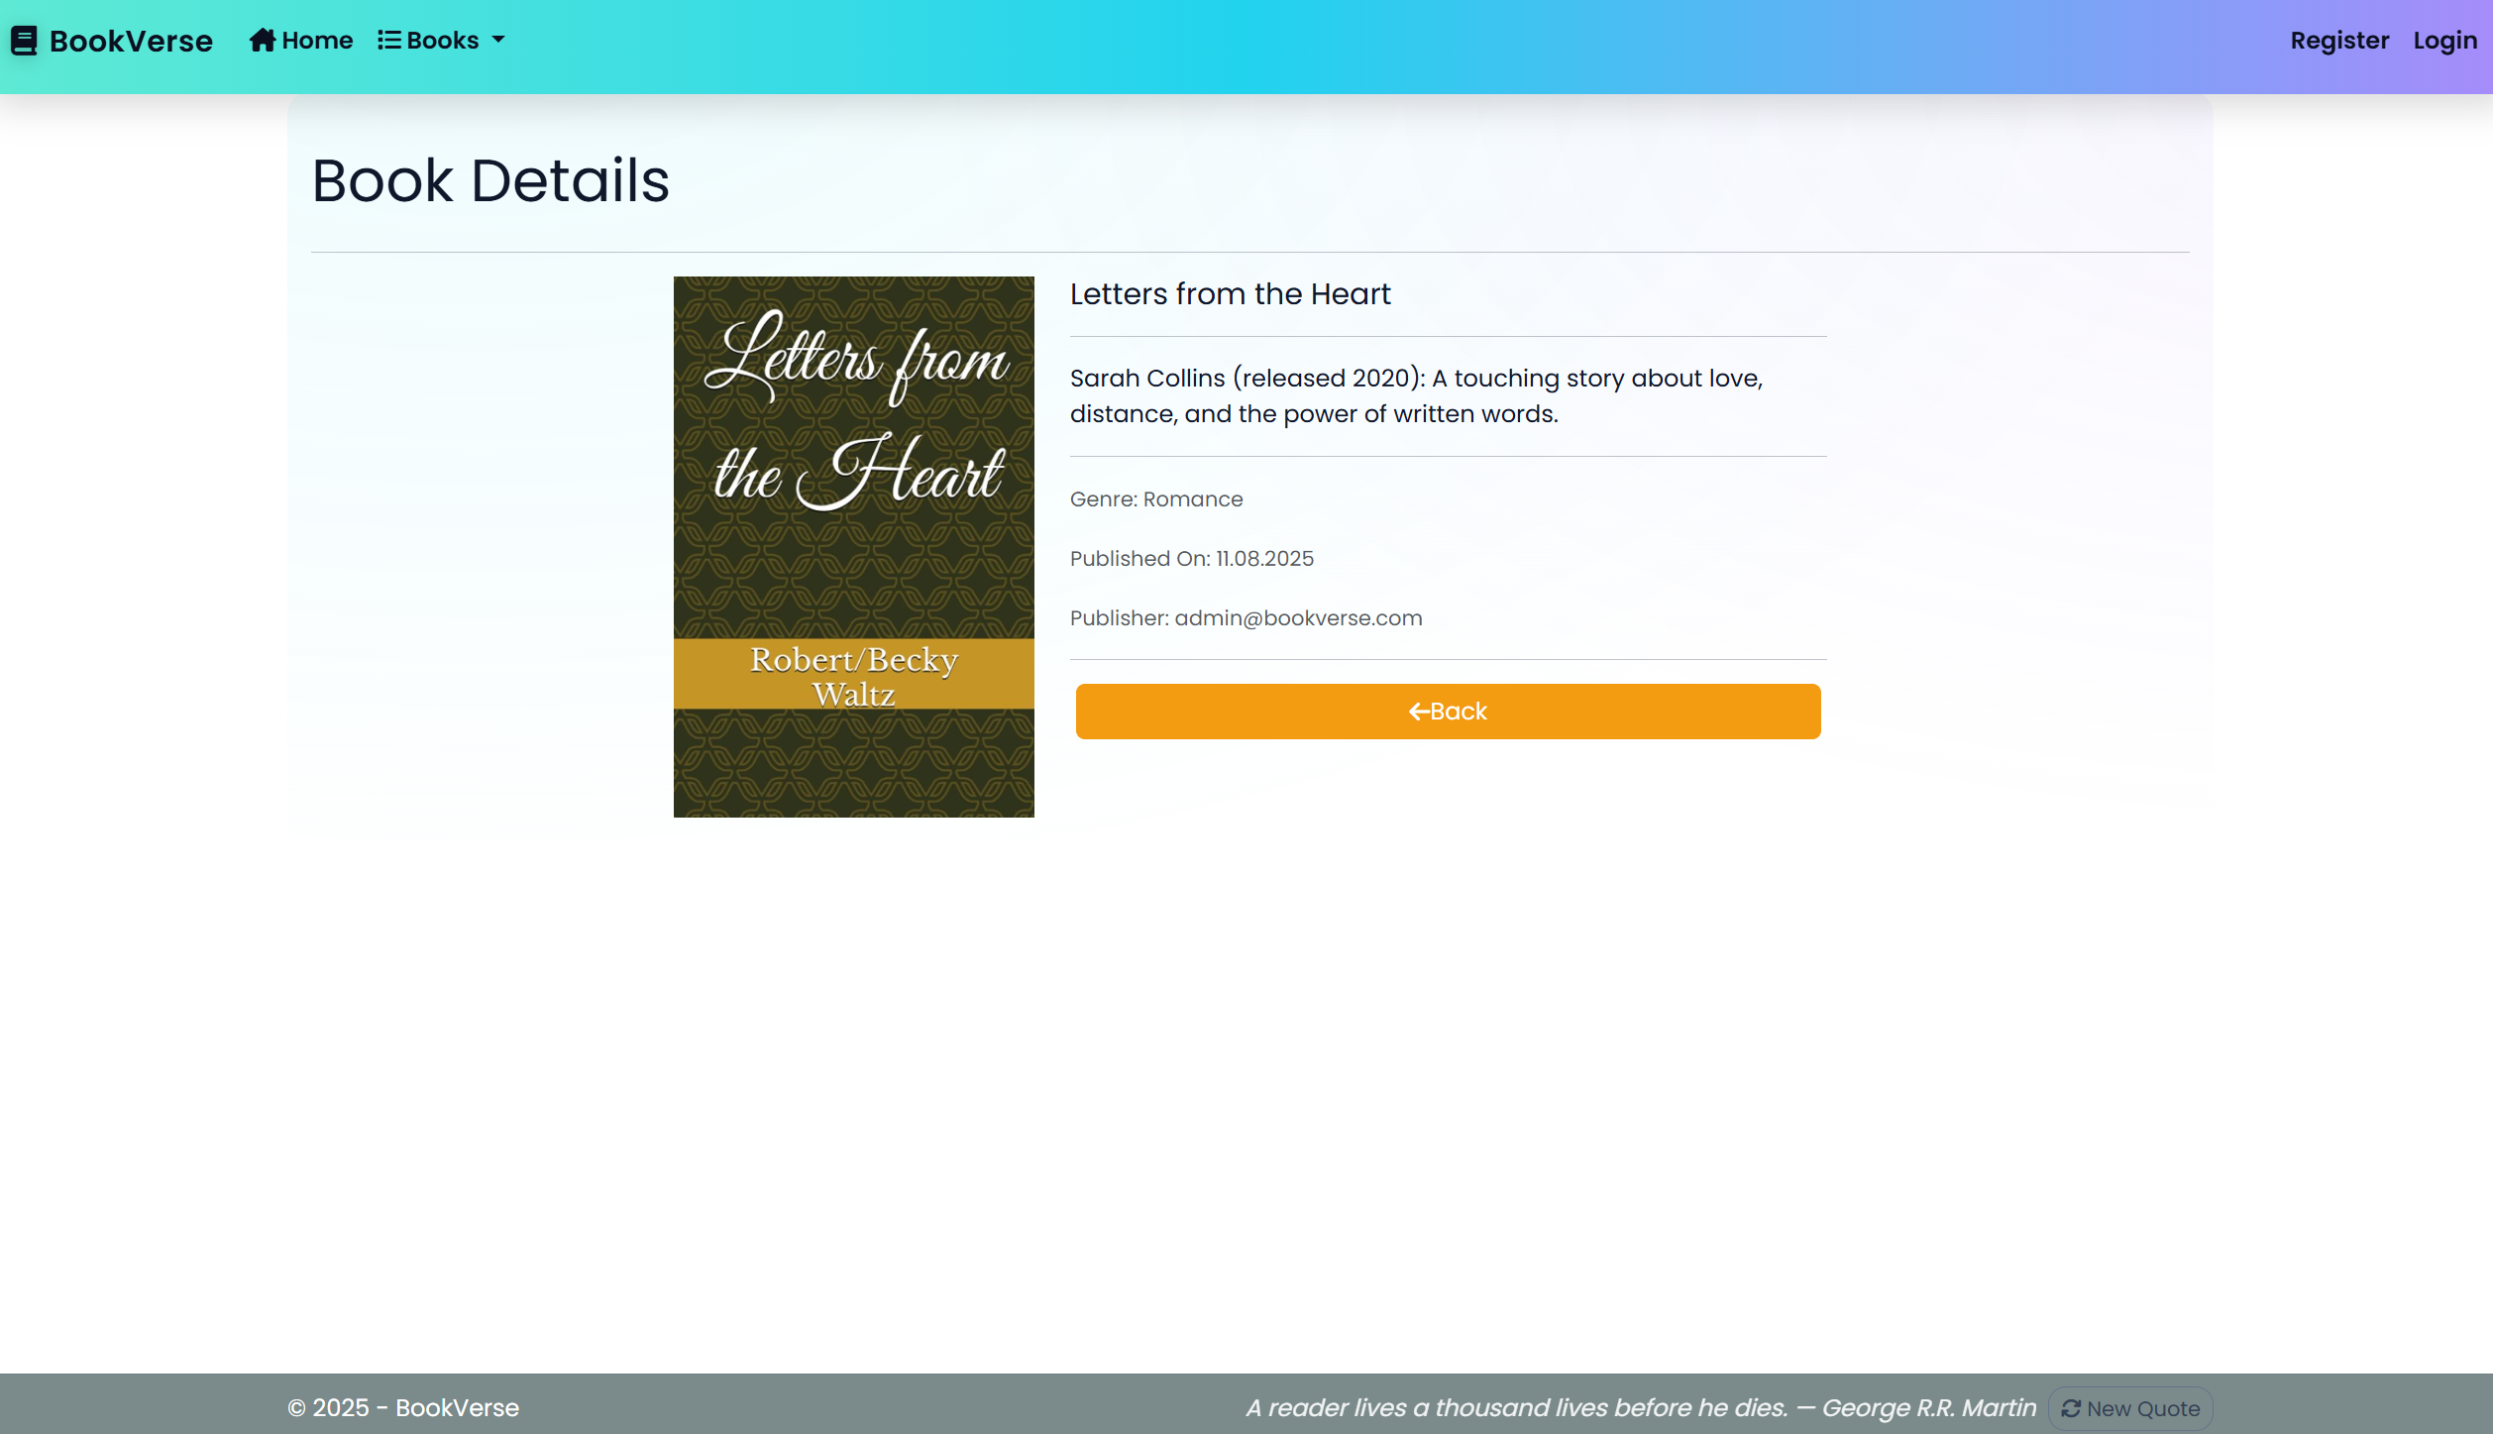

**NOTE**:

* If the **currently logged-in user is the publisher of the book**, the **"Delete"** and **"Edit"** buttons should be **visible**, allowing them full access to the book functionalities.
* If the **logged-in user is** **not the publisher** of the book, the **"Delete"** and **"Edit"** buttons should **NOT** be **visible**. The **"My Books"** button should be **visible**. This ensures that the **book publisher** and   
  **Not-author-users** have different application functionalities access.
* Guests (**unauthenticated users**) should be able to **access the book details page** but **won't have access to actions** like **adding to my books**, **editing**, or **deleting** a book.

### /Book/AddToMyBooks?id={id} (logged-in user)

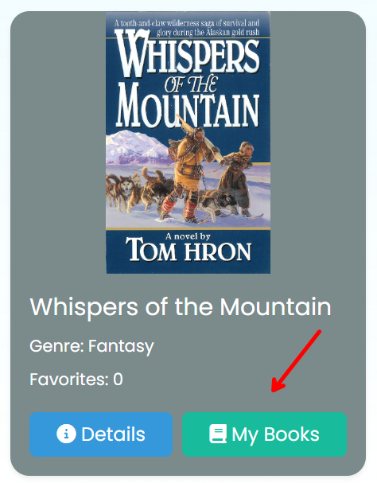

This **feature is accessible by the My Books button** in every book card and **adds the selected book to the user's collection of books**. If the book is **already in the collection**, it **should not be added again**. If the **addition is successful**, the users will **remain on the current page**, (either **Book/Index** or **Book/Details**) rather than being redirected to the MyBooks page.

### /Book/Remove?id={id} (logged-in user)

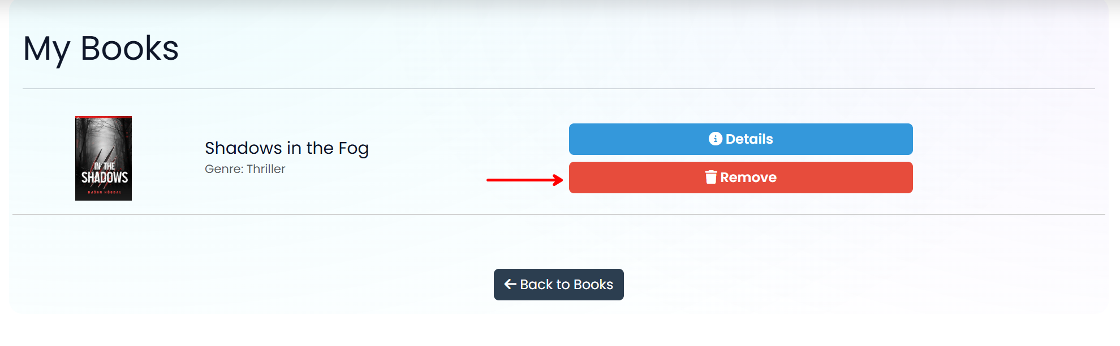

This **feature is accessible by the Remove button** in the "**/Book/MyBooks**" page and **removes the selected book** from the user's **collection of books**. If the **removal is successful**, the user will **remain on the current page** "**/Book/MyBooks**" page.

**NOTE**: The templates should look **EXACTLY** as shown above.

**NOTE:** the **DateTime** format is recommended, if you are having trouble with the one in the image, you are **free** to use **another** one.

**Book/Delete/{id} (logged-in user, publisher of a book)**

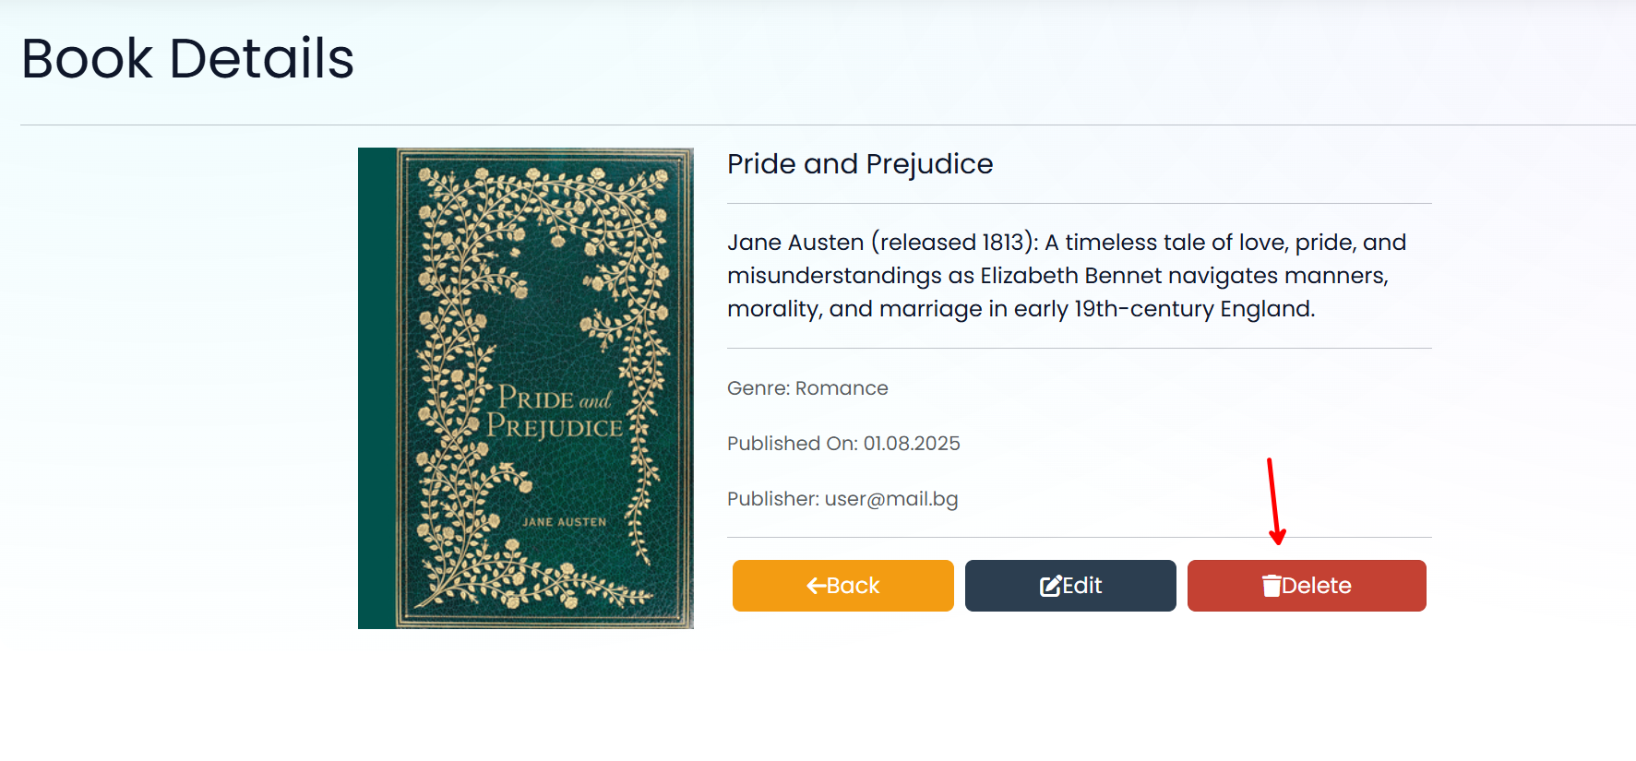

When a **logged-in user** who is the **publisher of a book** accesses this page, they can initiate the deletion of the book. This process uses **soft delete functionality**, meaning the **book will remain in the database** but will **no longer appear in book listings** or be accessible to users.

**Book/ConfirmDelete/{id} (logged-in user, publisher of a book)**

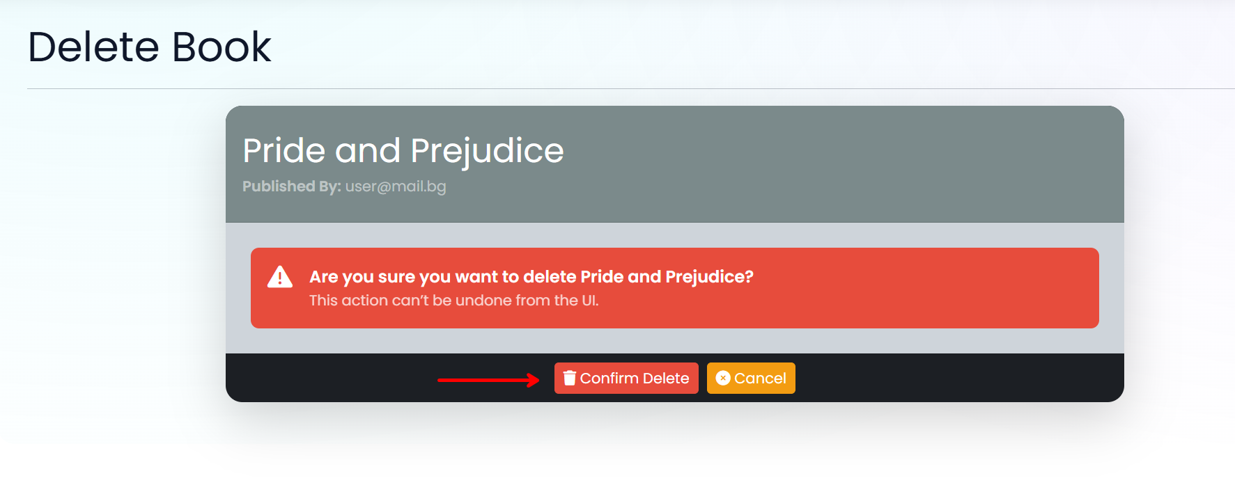

**After confirming the deletion**, the publisher will be **redirected to the Book controller's Index action**. This operation is **one-directional and irreversible through the user interface**. Once deleted, a **book will not be displayed** in the application **unless it is manually restored** via the database.

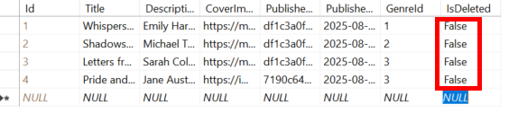

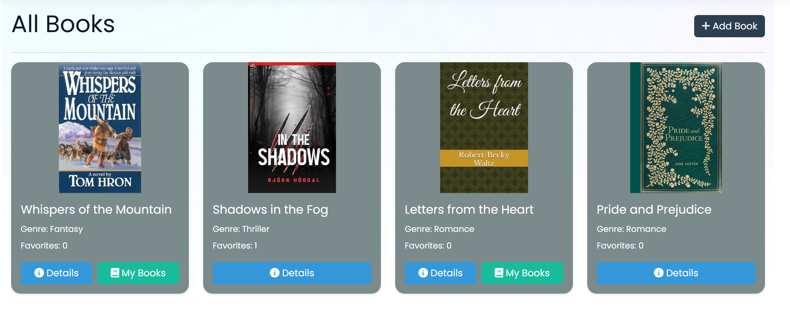

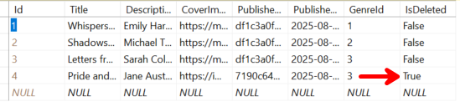

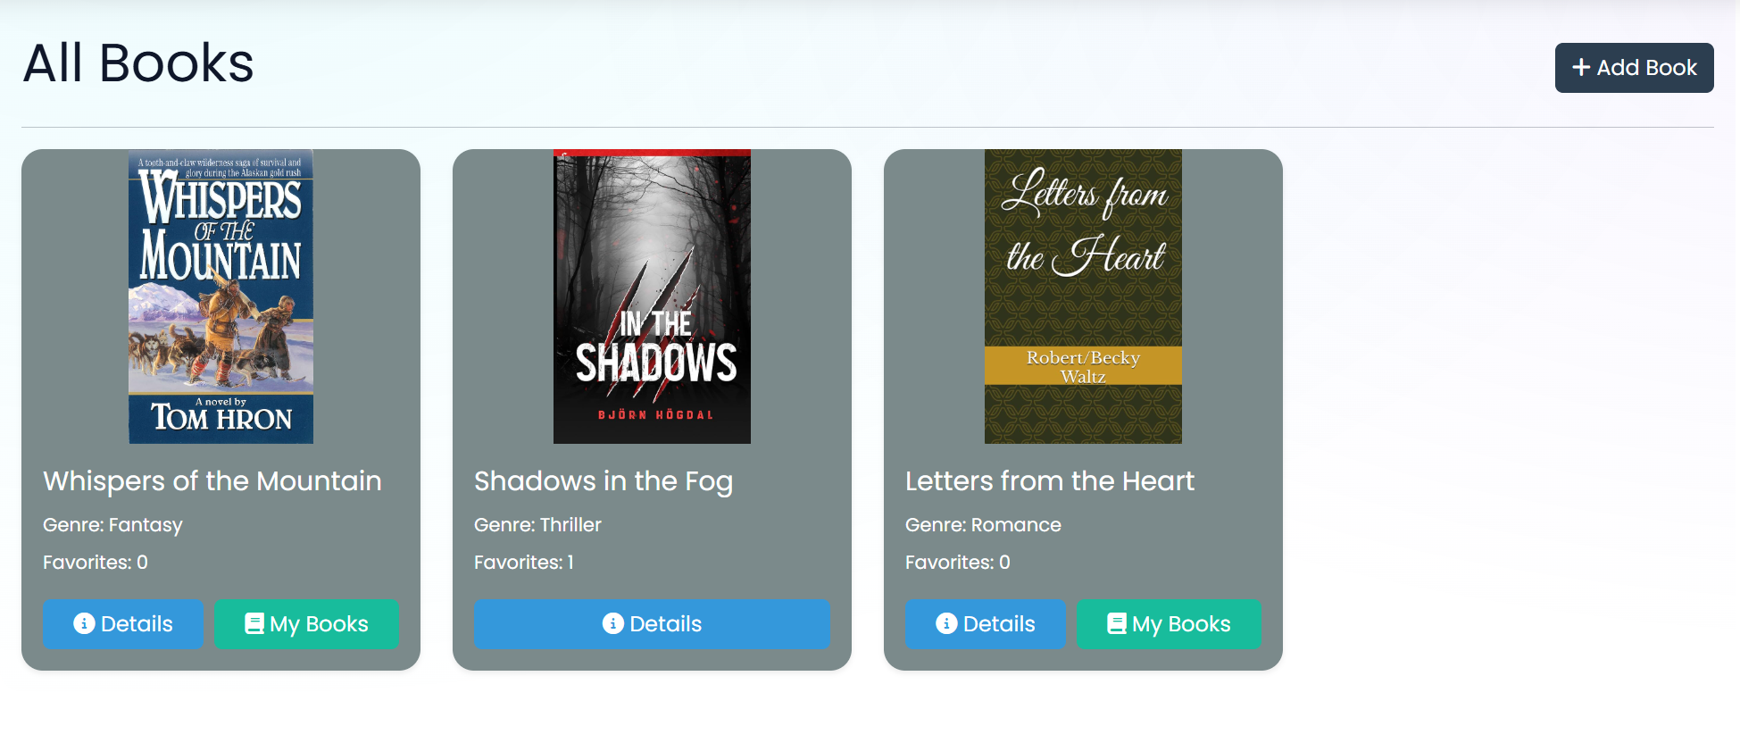

**Cancel Button Behavior**

The **Cancel button** in the **Delete Book** view is configured to **return the user to the Details page** of the book they chose not to delete.

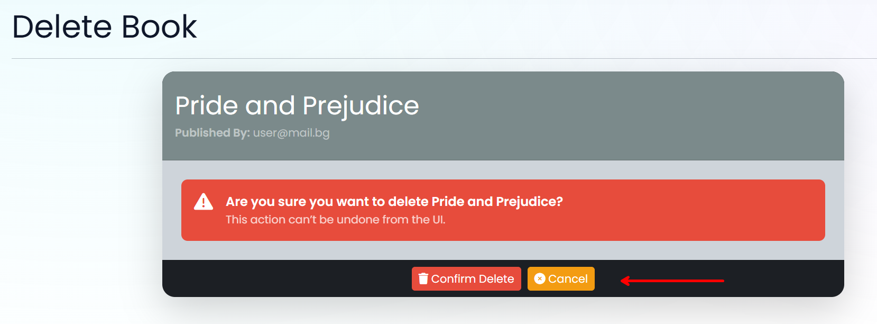

## Functionality

**BookVerse** is a very simple application.

### Users

Guests can Register, Login and view the **Home Page**, Index Page and Details Page.

**Logged-in users** can **publish** books and **edit** books **they have published**.

Users (**guest-users + logged-in-users**) can **view all published books**, including those by other users, on the **Home Page** (**/Book/Index**).

If the **user is the publisher of a book**

* They **can't see** the **[My Books]** button
* They can see the **[Details]** button

If the user is **not the publisher** of the book, they can only add the book to their collection **[My Books]**.

### Book

A Book can be **added** by **logged-in-**users. All added books are visualized on the Home Page (/Book/Index) with **some** of their associated **information**.

Books are visualized on the Index Page (/Book/Index) with **one or two buttons**:

* If the user **IS NOT** the **publisher** of the book – **[Details][My Books]**
* If the user **IS** the **publisher** of the book – **[Details]**

The **[My Books]** button adds the book to the user's collection of favorite books (My Books) **unless it is already added**.

The **[Details]** button displays a new page with the full information for the selected book. The actions and buttons displayed on this page will vary depending on the user's identity and role:

* **Guest (Not Logged In)**:  
  The user can see the **full details of the book** but will **not be able to add to My Books collection**, **edit**, or **delete** the book. No action buttons **[My Books]**, **[Edit]**, **[Delete]** will be shown.
* **Logged-in User (Not the Publisher)**:  
  The user will **see the full details** of the book and will **have access to [My Books]** button, allowing them to **add a book to their collection of favorite books** (if it has not already been added). The **[Edit]** and **[Delete]** buttons will not be displayed as they are **not the publisher** of the book.
* **Publisher of the Book**:  
  The publisher will have **full access to the book details** and will be able to see both the **[Edit]** and **[Delete]** buttons. However, the **[My Book]** button will not be displayed since the publisher cannot add their own book.

The **[Edit]** button displays a new page with a form, filled in with **all** of the **info** for the **selected** **book**. Users can **change this info and save it**.

Usershave a My Books page where only the booksthey have selected as favorites are displayed.

* The **[Remove]** button **removes** the selected **book** from the **user's my books** collection.

### Redirections

* Upon successful Login of an **IdentityUser**, you should be redirected to the /Book/Index
* Upon successfully Publishing a Book, you should be redirected to the /Book/Index
* Upon successfully Adding a **Book** to the **User's My Books**, you should **remain on the current page**, (either **Book/Index** or **Book/Details**)
* Upon successful **Editing** of a **Book,** you should be redirected to **/Book/Details/{bookId}**
* Upon successful Removal of a **Book** from the **User's My Books collection**, should be redirected to the /Book/MyBooks
* If a User **adds** a book to **My Books** collection, the **[My Books]** button **disappears**, and the user should not be able to duplicate books in the **collection.**
* Upon successful Logout of a User, you should be redirected to the Home Page
* If any of the **validations** in the POST forms **don't pass**, **redirect** to the **same page** (**reload/refresh** it)

## Security

The Security section mainly describes access requirements.

**Users-only** pages (Create, Edit, MyBooks, Delete)

Configurations about which users can access specific functionalities and pages:

* Guest (not logged-in) users can access the Home page, **Book Index** page, and **Book Details** page
* Guest (not logged-in) users can access the Login page
* Guest (not logged-in) users can access the Register page
* Guests (not logged in) cannot access Users-only pages
* Users (logged in) cannot access Home page
* Users (logged in) can access the Book/Create page and functionality
* Users (logged in) can access the Book/Edit page and functionality
* Users (logged in) can access theBook**/MyBooks** page
* Users (logged in) can access Logout functionality
* Users (logged in) cannot access the Book/Edit page of a book that has another user as a publisher
* Users (logged in) cannot access the Book/Delete page of a book that has another user as a publisher

## Code Quality

* Make sure you provide the best architecture possible. Structure your code into different classes, and follow the principles of high-quality code (**SOLID**).
* All interaction with the database **must go through properly implemented services**.
* You will be scored for the Code Quality and Architecture of your project.

## Scoring

### Identity Requirements – 5 points

### Database Requirements – 10 points

### Template Requirements – 10 points

### Functionality – 50 points

### Security – 5 points

### Code Quality – 10 points

### Data Validation – 10 points